Group 2 – Placental Case
LT is a 21 yo G2P1001 who just moved here from Ohio. She presents for anatomic ultrasound at 24 weeks. She has a history of 1 prior cesarean section. She reports that she had an ultrasound in the first trimester showing a cesarean scar implantation, but she chose to continue the pregnancy.
You obtain the following image:

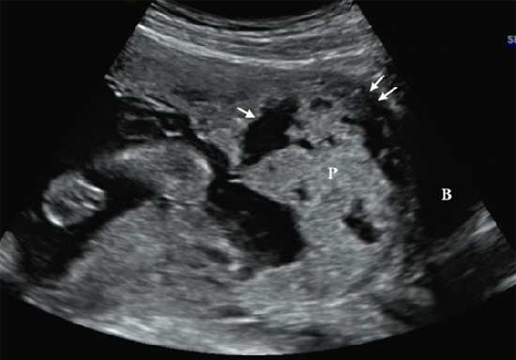

- Describe what you are seeing on ultrasound.

- What is your leading diagnosis?

- Why does this placental abnormality occur?

- What are the risk factors for this finding?

- Is ultrasound a good imaging modality for this diagnosis?

- What are your next steps in management?

- When would you deliver this patient?

