Williams Obstetrics Chapter 23 (Abnormal Labor) & 24 (Intrapartum Assessment)

CREOG Learning Objectives:
1. Define and describe abnormal labor, including diagnosis and management.
2. Perform and interpret intrapartum fetal monitoring:
- intermittent auscultation
- electronic fetal heart monitoring
a) Define and recognize normal and abnormal heart rate and variability
b) Define and recognize types of heart rate patterns
c) Describe appropriate interventions for abnormal fetal heart rate patterns

Practice Questions:
1. A 26-year-old woman, gravida 2, para 1, was admitted to the hospital for induction of labor at 41 3/7 weeks of gestation. Her cervical examination on admission was 3 cm dilated, 75% effaced, and -1 station with soft consistency. Induction was initiated with oxytocin, and after 6 hours the patient’s cervix was 6 cm dilated, 90% effaced, and +1 station. Artificial rupture of membranes was performed demonstrating clear amniotic fluid. Two hours later, her cervical examination was unchanged and an intrauterine pressure catheter was placed. The tocometer recorded 250 Montevideo units. Fetal heart rate tracing is category 1. The most appropriate next step in management is:
A. continue current management
B. decreased oxytocin use
C. increase oxytocin use
d. cesarean delivery
Source: Obstetrics Prolog 8th ed #60

2. A 23-year-old primigravid woman presents at 41 2/7 weeks of gestation for a late-term induction of labor. Her cervix is unfavorable, and she is treated with a cervical ripening agent followed by oxytocin. After 12 hours, she is contracting irregularly, and a cervical examination reveals she is 2 cm dilated, 50% effaced, and 0 station. Four hours later, she is contracting three times every 10 minutes and is comfortable with epidural analgesia. Fetal heart rate tracing is category 1. In another 4 hours, the patient is 4 cm dilated, 75% effaced, and 0 station. The most appropriate next step in management is to
A. continue oxytocin
B. discontinue oxytocin
C. start antibiotics
D. perform cesarean delivery
Source: Obstetrics Prolog 8th editions# 61

3. A 29-year old woman, gravida 3, para 2, at 38 weeks gestation is admitted to the labor and delivery unit for spontaneous rupture of membranes with clear fluid. Her medical and surgical histories are noncontributory. Her prenatal course has been uncomplicated. On initial examination, the patient’s vital signs are stable. Her cervix is 5 cm dilated, 70% effaced, and -1 station. The external fetal heart rate tracing is below and is unchanged with maternal positioning. The best next step in management of the patient is:

A. observation
B. tocolysis
C. amnioinfusion
D. immediate cesarean delivery
E. supplemental maternal oxygen
Source: Obstetrics prolog 8th ed #82

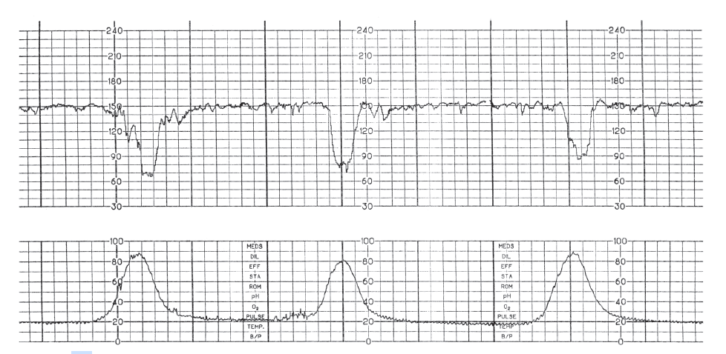

4. For each clinical scenario below, choose the most appropriate fetal heart rate tracing
A. Category I
B. Category 2
C. Category 3
D. Reactive NST
E. Nonreactive NST

Scenario 1: A 31-year old woman at 39 weeks of gestation presents with chorioamnionitis in active labor.

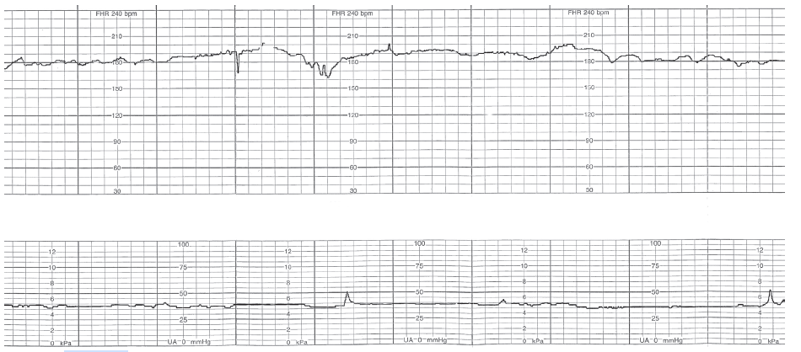

Scenario 2: A 21-year old woman at 31 weeks gestation is brought to the hospital after a motor vehicle collision. Vaginal examination discloses a closed, long cervix without evidence of rupture of membranes.

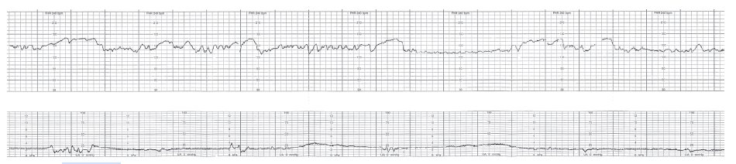
Scenario 3: A 39-year old woman at 41 weeks of gestation is completely dilated and effaced and pushing with contractions.
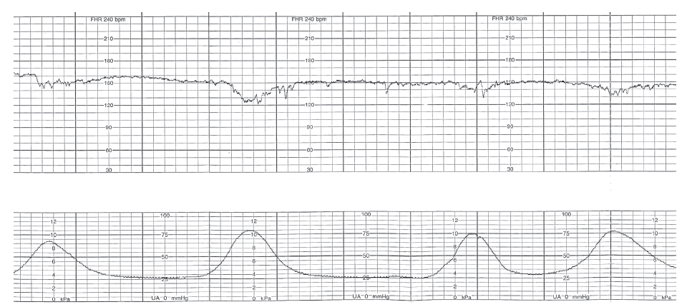
Scenario 4: A 23-year-old woman at 33 weeks gestation presents to triage with abdominal pain, vaginal bleeding, and a positive urine toxicology screen for cocaine. Vaginal exam discloses that the cervix is 7 cm dilated and 100% effaced.

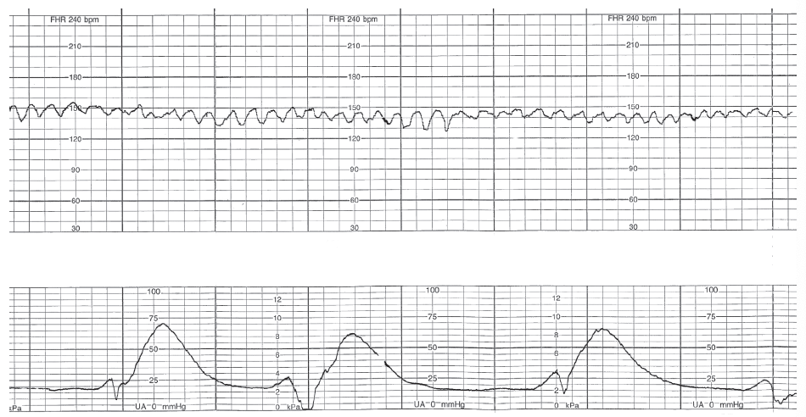
Scenario 5: A 19-year old woman at 42 weeks of gestation with limited prenatal care has meconium staining of the amniotic fluid and is in active labor.
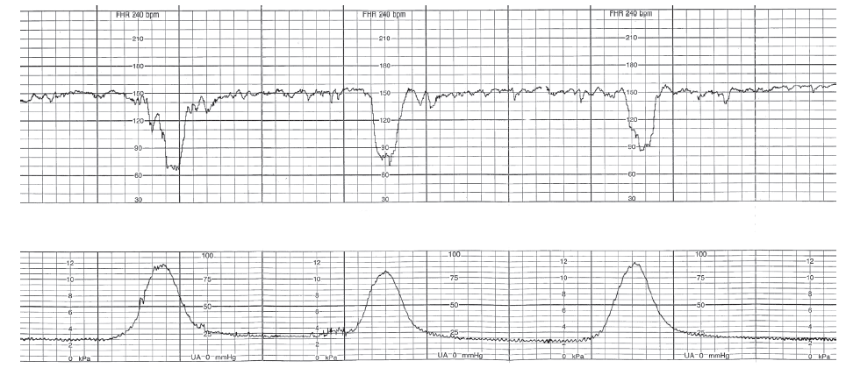

Scenario 6: A 27-year-old woman at 38 weeks gestation with preeclampsia with severe features is admitted for labor induction. During her initial evaluation before the onset of labor, vibroacoustic stimulation is attempted at the indicated arrow.

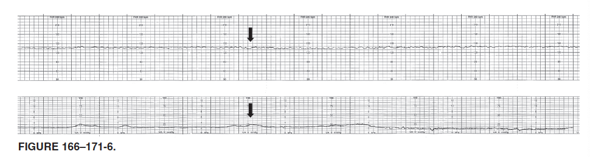
Source: Obstetrics prolog 8th ed #166-171

High-yield resources:

1) ACOG Obstetric Care Consensus: Safe Prevention of the Primary Cesarean Delivery
2) Practice Bulletin #116: Management of Intrapartum Fetal Heart Rate Tracings
3) Practice Bulletin #106: Intrapartum Fetal Heart Rate Monitoring: Nomenclature, Interpretation, and General Management Principles

Answers:
1) a 2) a 3) c 4) scenario 1: b scenario 2: d scenario 3: a scenario 4: c scenario 5: b scenario 6: e

