CREOG Review 12/17/20

Per Dr. Olson-Chen:

The good news is that there were only 3 REI-specific questions that more than 50% of the residents missed. I have included a list of the topics that >1/3 of the residents missed instead.

Here are the CREOG topics (some overlap):
- Hyperprolactinemia (Williams textbook of endocrinology)
- Risk factors for ovarian hyperstimulation syndrome (Speroff)
- Risks associated with hyperprolactinemia (Speroff)
- Congenital adrenal hyperplasia management (Speroff)
- Gonadotropin-releasing hormone agonist therapy (Speroff)
- Management of hydrosalpinx discovered on hysterosalpingography (ACOG PB No. 195)
- Risks associated with congenital urogenital anomalies (ACOG CO No. 728)
- Infertility evaluation (ACOG CO No. 781)

Review session format:

10:00-10:15: Answer and grade questions on your own, review algorithms

10:10-10:15: Turn on your camera when finished and enter 3 questions or topics that you would like to review in the chat

10:15-11:00: Group question or topic review

1. Which of the following medications is associated with hyperprolactinemia?
- citalopram
- fluoxetine
- risperidone
- quetiapine

2. Which of the following is a consequence of hyperprolactinemia?
- osteopenia
- mastalgia
- endometrial polyps
- lactation failure

3. Which of the following is the next best step when evaluating a mildly elevated prolactin level (20-40 ng/ml)?
- pituitary MRI
- growth hormone level
- formal visual field testing
- repeat prolactin level

4. Which of the following is the most likely menstrual disturbance associated with a mildly elevated prolactin level?
- amenorrhea
- oligomenorrhea
- short luteal phase

5. Which of the following the best recommendation for patient with a microadenoma who conceives while on bromocriptine?
- monitor prolactin levels and adjust therapy accordingly
- stop bromocriptine after the first trimester
- stop bromocriptine with a positive pregnancy test
- switch bromocriptine to cabergoline

6. Which of the following is a risk factor for ovarian hyperstimulation syndrome?
- polycystic ovary syndrome
- leuprolide trigger
- diminished ovarian reserve
- GnRH antagonist protocol

7. Which of the findings would warrant hospitalization for careful monitoring and aggressive treatment in a patient diagnosed with OHSS?
- weight gain of 4 lbs
- sodium <135 mEq/L
- hematocrit <35%
- creatinine <1.0 mg/dl

8. Which of the following is the appropriate management of a patient with congenital adrenal hyperplasia to prevent virilization of the fetus?
- start dexamethasone with a positive pregnancy test
- start hydrocortisone with a positive pregnancy test
- perform a CVS with genotyping and sex determination

9. Which of the following is the best initial treatment for hirsutism in a patient with congenital adrenal hyperplasia?
- glucocorticoids
- metformin
- spironolactone
- oral contraceptive pills

- Which of the following is a safe and effective treatment for a female patient with idiopathic gonadotropic-dependent precocious puberty?
  - leuprolide
  - letrozole
  - tamoxifen
  - estradiol

- Which of the following is an appropriate indication for GnRH agonist treatment for myomas?
  - long-term resolution of myomas
  - improved dissection at myomectomy
  - improved anemia prior to myomectomy
  - reduced length of hospital-stay after myomectomy

- Which of the following is the appropriate therapy when a hydrosalpinx is found by hysterosalpingogram?
  - ceftriaxone
  - metronidazole
  - doxycycline
  - ceftriaxone and doxycycline

- Which of the following screening tests should be performed in a sexually active 23-year-old patient with mullerian agenesis?
- Pap test
- HPV test
- chlamydia
- urinary analysis

14. A 25-year-old nulligravid woman would like to conceive with her male partner. She has a history of treatment of stage IV endometriosis and recently stopped continuous combination oral contraceptive pills. They have been trying to conceive for 2 months. Which of the following is the most appropriate next step?
  - return in 10 months for an infertility evaluation
  - return in 4 months for an infertility evaluation
  - immediate infertility evaluation
  - immediate infertility treatment

15. A 36-year-old nulligravid woman would like to conceive with her male partner. They have been trying to conceive for 6 months. She has 28 day cycles and detects an LH surge on day 12. Her AMH level is 1.8 ng/ml. She completed a hysterosalpingo-contrast sonogram confirms tubal patency of at least one tube and a normal appearing uterine cavity. Her partner completed a semen analysis with the following parameters: volume 1.5 ml, sperm concentration 35 million per ml, total sperm concentration 52.5 million, total motility 55%, sperm morphology 5% normal forms. The most likely diagnosis is:
- male factor
- unilateral tubal factor
- diminished ovarian reserve
- unexplained infertility

Other algorithms (from Speroff’s textbook) that you should understand prior to the CREOG:

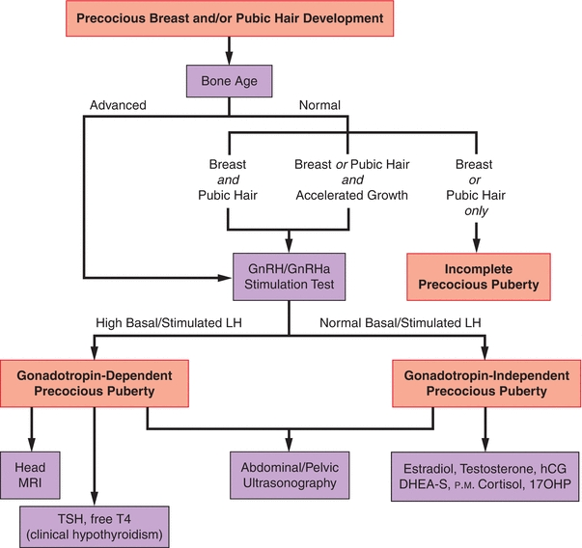

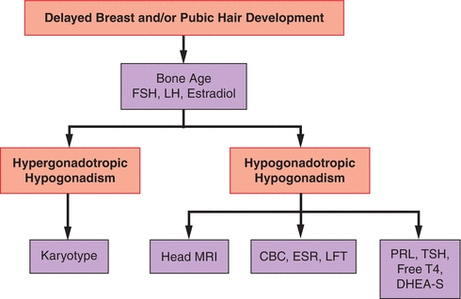

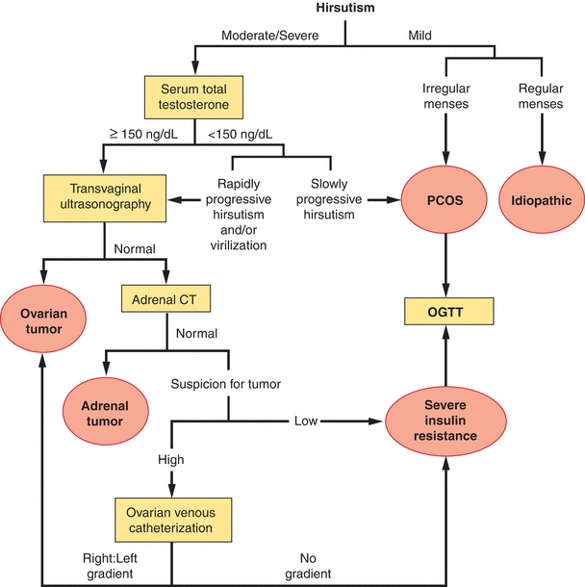

Amenorrhea evaluation
