We are dedicated to creating a learning environment that supports both your educational needs and your health and well-being. In addition to the UR Medical Faculty and Clinician Wellness program, we have a Resident/Fellow Wellness Committee to evaluate and support your specific needs. The AMA has identified 6 key areas on which personal wellness depend and UR and its programs are working to address each one:
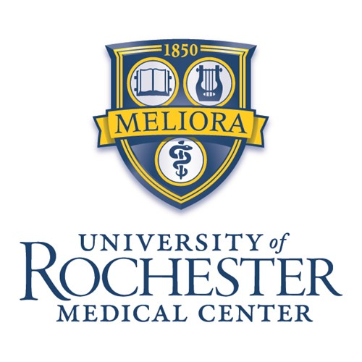
UR Resident & Fellow Wellness Program

1. Nutrition. A variety of healthful food options are available at UR including Café 601, the Metro Deli, Finger Lakes Coffee Roasters and the restaurants at College Town. To accommodate trainees on night shifts, UR Café 601 offers nighttime hours and local restaurants offer delivery service to the hospital lobby. Individual UR programs have taken a variety of approaches including set meals at midday conferences or maintaining a stocked resident refrigerator/snack cabinet. UR also sponsors a weekly Farmers’ Market on –site from March to October: http://rochester.edu/working/hr/wellness/market/ .
2. Fitness. To help make it easier for you to remain physically active, discounted membership at the on-site URMC Fitness Center is available to all trainees- includes a fully equipped gym open 24-, yoga, Zumba, WERQ®, karate, power pump, ballet/barre, and an early morning “boot camp” at 6:30am. Personal training is also available for under $20 a session. https://www.urmc.rochester.edu/fitness-center.aspx. UR has partnered with the YMCA of greater Rochester, offering discounted memberships & programs- checkout the latest location near the hospital: https://rochesterymca.org/schottland/ . The Well-U program at UR provides free programs to promote good health for all employees: https://www.facebook.com/urwellu/ .
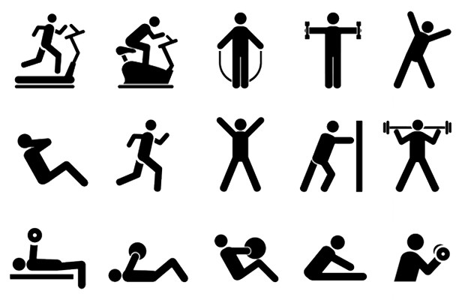
3. Emotional health. Mindfulness meditation, stress reduction, retreats, support groups, mentorship, & safe haven discussions of difficult issues are all addressed at UR. To encourage and empower trainees to seek help as needed, we offer free and confidential 24-7 access to our Employee Assistance Program (EAP) for help with personal or work-related crises, stress management, and mental health needs. All trainees have rapid access to UR Behavioral Health Partners as needed for longer-term counseling & support. To support the development of relationships and a sense of community, UR leadership sponsors social events throughout out the year such as the Food Truck Rodeo and any programs hold their own and joint social activities with other programs.
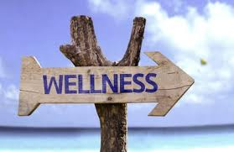
4. Preventive care. We value your attention to your own health as you ensure the health of our patients. UR programs support our trainees in scheduling acute and routine doctor appointments as needed. Our on-site faculty practice is open to all trainees and their families seeking a primary care provider. UR assists trainees with free routine vaccination updates (including flu) and screening at the annual health update through Occupational Medicine.
5. Financial health. Our programs have developed specialty-specific education to promote your financial wellbeing. These offerings have included curricula to promote your knowledge in the business of medicine, ensure your comfort in contract negotiation and to assist you in short and long-term financial planning.
6. Mindset and behavior adaptability. “Meliora” - that’s our motto and we are always seeking to be better at UR. To that end, we have empowered all of our trainees to help themselves by providing them the appropriate self- screening tools (anonymous 24-7 web access to the Well-Being Index), coaches (faculty and peers), support groups and team training. https://www.urmc.rochester.edu/education/graduate-medical-education/wellness.aspx
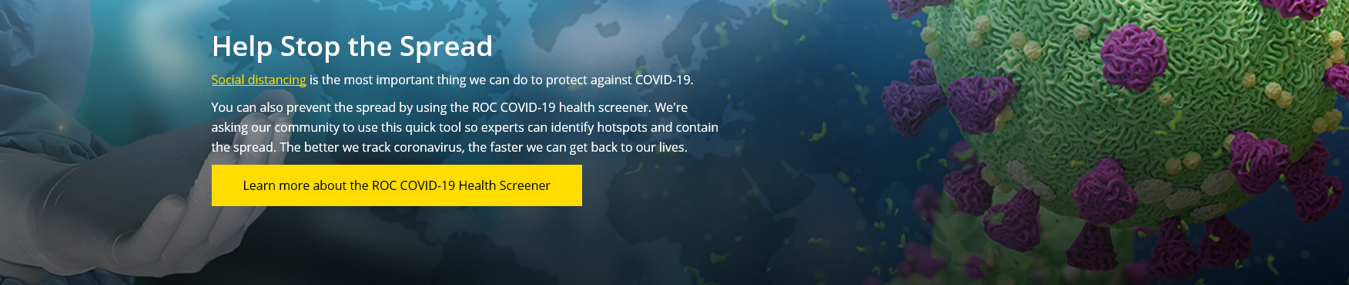

In partnership with state and local government, URMC has been the regional leader in pandemic management. The safety and education of our residents & fellows, who are both learners and essential health care workers, have been a primary consideration in development of the institutional pandemic response. The institution has maintained a robust communication system, including a dedicated webpage & email communication plan, to ensure trainees and program receive the most up-to-date information. Residents and fellows have had a voice in development of the pandemic management plan through GME and as members of institutional and departmental committees involved in the planning. Fortunately, Western NY was able to rapidly flatten its curve and maintain very low levels of COVID-19 prevalence and illness- and we are ready to respond rapidly to any changes in COVID-19 status in the coming months.
Some examples of pandemic management strategy relevant to trainees:

- At the start of the pandemic response, GME and program director representatives from the hospital-based, medical, and surgical programs developed a system of ED, floor, and ICU coverage based on level of training and skills attainment, ensuring trainees would be assigned appropriately and have robust supervision while caring for COVID patients. No trainees actually had to be pulled to cover unfamiliar clinical areas- although many indicated their readiness to pitch in wherever needed!
- Program directors & residents, in collaboration with institutional leadership, identified ways to support faculty and trainees working more frequently on the “front lines”. One example is creation of a “surgical ED” where all ED patients presenting with a potentially surgical issue were triaged to a separate clinical area for immediate evaluation by an assigned surgical team. Similar plan for OB-GYN patients- but we never needed it!
- Most programs instituted rotating 1 week on-1 week off (or similar) schedules to minimize trainee exposure, allow adequate rest & recovery, and allow time for continuing educational activities.
- Fortunately, URMC did not experience a PPE shortage similar to those we have seen in media reports. URMC has employed new technologies and protocols to optimize use of PPE and create a stockpile for future needs.
- Although ACGME guidelines permitted focus on pandemic-related patient care duties, most of our programs maintained their didactic and educational programs with minimal disruption through rapid adoption of virtual learning modalities.
- While many of our training programs incorporated telemedicine training pre-COVID, all of our programs quickly incorporated this technology to ensure patient access to care. The institution supported rapid credentialing and training for our faculty & trainees. With clinical care activities back to pre-pandemic levels, a substantial portion of care continues via telemedicine- a great skill to have!
- With travel restrictions and social distancing requirements, the usual interviewing and new resident orientation processes have gone virtual! Our programs were early adopters of virtual interviews and are working with the institution to ensure our 2020-21 interview process provides you with the information you need to inform your match experience. We hope to see you here next year!
What about Coronavirus (COVID-19)?

